**ENGLISH NOTES**

**GRADE THREE**

KWA MUENDELEZO WA NOTES HIZI TUONE INBOX

0747249620

**2023**

1. **COMPREHEND ORAL AND WRITTEN INFORMATION**
   1. Listen and Comprehend information presented orally.
   2. Listen and comprehend the phonemic symbols.
   3. Listen pronounce and read phonemic symbols.
2. **COMMUNICATE ORALLY AND THROUGH WRITING**
   1. Communicate through speaking.
   2. Communicate through writing
3. **DEVELOP AND USE VOCABULARY THROUGH THE FOUR LANGUAGE SKILLS.**
   1. Develop and use vocabulary through listening and speaking.
   2. Develop and use vocabulary through reading.
   3. Develop and use vocabulary through writing.

**1.0 COMPREHEND ORAL AND WRITEN INFORMATION**

**1.1Listen and comprehend oral information**

Comprehension – Is a process of understanding the information completely.

Oral information – Is a process of expressing the information by the word of mouth.

Listening – Is to pay attention in order to understand the oral information.

Hearing – Un intentionally action of receiving sound waves.

1. **Listen in order to recognize all familiar words and basic phrases concerning self, family and immediate surroundings.**

**Introducing myself and my family**.

Family – Is a group of people consist of father, mother and children living together.

Family members

* Father
* Mother
* Sister
* Brother
* Uncle
* Aunt
* Grand father
* Grand mother
* Sister – in – law
* Nephew
* Niece
* Cousin
* Brother – in – law

Exercise

1. What is your name?
2. How old are you?
3. What is your father’s name?
4. What is your mother’s name?
5. What is your tribe?
6. Where do you live?
7. How many brothers do you have?
8. How many sisters do you have?

Introducing my family

1. The father of your father or mother is called a **grandfather.**
2. The mother of your father or father is called a **grandmother.**
3. The sister of your mother or father is called **aunt.**
4. The brother of your father or mother is called **uncle**
5. A male parent is called a **father**.
6. A female parent is called a **mother.**
7. The child of your aunt or uncle is called a **cousin**.
8. The son of your sister or brother is called a **nephew**.
9. The daughter of your brother or sister is called **a niece.**

**Reading practice introducing myself**

My name is David. I am eight years old. My father’s name is Mwasha and my mother’s name is Lyimo. Please call my mother Mrs. Mwasha.

My mother is a primary school teacher and my father is a pilot. I have two brothers and one sister. We all live with our parents in Dodoma Region. My uncle and grandparents live in Iringa Region.

II am a pupil atMsalato Primary School. It is one of the best schools in the region.



The head teacher of the school is called Mr. John. Most of the parents love him because the school performs well under his leadership. The school owns a bus, therefore transport to and from school is not a problem.

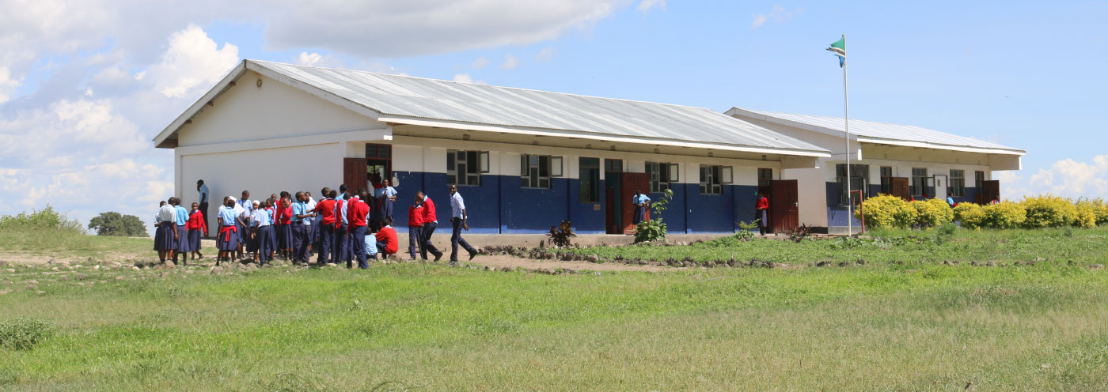

Boys wear cream and brown shorts. Girls wear cream shirts and brown skirts. We also wear white socks and black shoes.

My friends and I exchange stories during tea and lunch breaks. I enjoy telling stories.

My class teacher, Miss Rose, loves me because I am obedient and active in class. I am responsible both inside and outside the classroom. Grade three members elected me their class monitor.

I like football more than any other game. This is the game I play during games. I have a dream of being one of the players of Taifa Stars Football Team.

On weekends, my parents sometimes take me out. We either visit relatives and friends or go to recreational places. I like swimming. I am a good swimmer too.

**List of items that are found in environment**

* Trees
* Nursery play ground
* Toilet
* Gate
* Teachers
* Mosque
* Flowers
* House
* Window
* Office
* Desks
* Classroom
* Cars
* Bicycles
* Goats
* Duck
* Dog
* Window
* Shop
* Plant
* Furniture
* Televisions
* Mats
* Utensils
* Fridge
* Radio
* Tiles
* Matron
* Tables
* Play grounds
* Buildings
* Books
* Electricity

**b.Listen in order to comprehend the main points in short, clear and simple messages and announcements**.

**Message**: Is a spoken or written piece of information which contains some information, news, advise, request sent by a messenger through phone, email.

Example

Dear dad and mom. We are now in Morogoro town. Yesterday, we visited Mikumi National Park. We saw different animals. It is beautiful park.

Your son, Juma

KWA MUENDELEZO WA NOTES HIZI TUONE INBOX

0747249620